Tuesday, November 20, 2018

CHAPTER 3

2 Ω

3 A

6 Ω

7 Ω

3 A

12A

12A

1

i₁

i₁

i₂

i₃

2

P.P.3.1

At node 1,

–3 + i₁ + i₂ = 0 or = 3

or 4v₁ – v₂ = 18 (1)

At node 2,

–i₁ + i₃ + 12 = 0 or i₁ = 12 + i₃ or

or 7v₁ – 13v₂ = 504 (2)

Solving (1) and (2) gives

v₁ = –6 V, v₂ = –42 V

v₃

3 Ω

4 A

2 Ω

4 Ω

i₁

i_{x}

i₂

i₂

4i_{x}

i₃

v₂

v₁

6 Ω
P.P.3.2

At node 1,

–4 + i₁ + i₂ = 0 = –4 +
or 5v₁ – 2v₂ – 3v₃ = 24 (1)

At node 2,

–i₂ + i_{x} – 4i_{x} = 0 = –i₂ – 3i_{x} = 0 where i_{x} = [(v₂–0)/4] or
which leads to 4v₁ + 5v₂ = 0 (2)

At node 3,

–i₁ + i₃ + 4i_{x} = 0 =

or –3v₁ + 6v₂ + 4v₃ = 0 (3)

Solving (1) to (3) gives

v₁ = 32 V, v₂ = –25.6 V, v₃ = 62.4 V

P.P.3.3
–+

6 V
+
v
–

+
v₁
–

v

(a)
–
+
14V

v₁
+
v
–

4 Ω

3 Ω

2 Ω

6 Ω

(b)

–

At the supernode in Fig. (a),

or 42 = 7v + 8v₁ (1)

Applying KVL to the loop in Fig. (b),

– v – 6 + v₁ = 0 v₁ = v + 6 (2)

Solving (1) and (2),
v = –400 mV

v₁ = v + 6 = 5.6, i₁ =
i₁ = 2.8 A

P.P.3.4

(a)

v₁

v₂

v₃
+ –

25 V
+
v₂
–

(b)
+
–

+
v₁
–

+
v₃
–

5i

From Fig. (a),

6v₁ + 3v₂ + 4v₃ = 0 (1)

From Fig. (b),

– v₁ + 25 + v₂ = 0 v₁ = v₂ + 25 (2)

– v₂ – 5i + v₃ = 0 v₃ = v₂ + 2.5v₁ (3)

Solving (1) to (3), we obtain

v₁ = 7.608 V, v₂ = –17.39 V, v₃ = 1.6305 V

P.P.3.5 We apply KVL to the two loops and obtain

–45 + 2i₁ + 12( i_{i} – i₂) +4i₁ = 0 or

–45 + 18i_{i} – 12i₂ = 0 which leads to 3i_{i} – 2i₂ = 7.5 (1)

12(i₂ – i₁) + 9i₂ + 30 + 3i₂ = 0 or

30 + 24i₂ – 12i₁ = 0 which leads to –3i₁ + 6i₂ = –7.5 (2)

From (1) and (2) we get

i₁ = 2.5 A, i₂ = 0A

P.P.3.6 For mesh 1,

–16 + 6i₁ – 2i₂ – 4i₃ = 0 3i₁ – i₂ – 2i₃ = 8 (1)
For mesh 2,

10i₂ – 2i₁ – 8i₃ – 10i₀ = 0 = –i₁ + 5i₂ – 9i₃ (2)

But i₀ = i₃,

18i₃ – 4i₁ – 8i₂ = 0 –2i₁ – 4i₂ + 9i₃ = 0 (3)

From (1) to (3),

=

= 135 – 8 – 18 – 20 – 108 – 9 = –28

i₁ ₌ i₂ = , i₃ =

I_{o} = i₃ = –4 A

P.P.3.7

(b)

4 Ω

8 Ω
–
+

2 Ω

2 Ω

i₃

i₂

i₁

i₁

4 A
–
+
8 V

1 Ω

2 Ω

2 Ω

4 Ω

8 Ω

3 A

i₂

i₂

i₁

i₃

(a)

0

For the supermesh,

–8 + 2i₁ – 2i₃ + 12i₂ – 4i₃ = 0 or i₁ + 6i₂ – 3i₃ = 4 (1)

For mesh 3,

8i₃ – 2i₁ – 4i₂ = 0 or –i₁ – 2i₂ + 4i₃ = 0 (2)

At node 0 in Fig. (a),

i₁ = 4 + i₂ i₁ – i₂ = 4

Solving (1) to (3) yields

i₁ = 4.632 A, i₂ = 631.6 mA, i₃ = 1.4736 A

P.P.3.8 G₁₁ = 1/(1) + 1/(20) + 1/(5) = 1.25, G₁₂ = –1/(5) = –0.2,

G₃₃ = 1/(4) + 1 = 1.25, G₄₄ = 1/(1) + 1/(4) = 1.25,

G₁₂ = –1/(5) = –0.2, G₁₃ = –1, G₁₄ = 0,

G₂₁ = –0.2, G₂₃ = 0 = G₂₆,

G₃₁ = –1, G₃₂ = 0, G₃₄ = –1/4 = –0.25,

G₄₁ = 0, G₄₂ = 0, G₄₃ = 0.25,

i₁ = 0, i₂ = 3+2 = 5, i₃ = –3, i₄ = 2.

Hence,

P.P.3.9 R₁₁ = 50 + 20 + 80 = 150, R₂₂ = 20 + 30 + 15 = 65,
R₃₃ = 30 + 20 = 50, R₄₄ = 15 + 80 = 95,

R₅₅ = 20 + 60 = 80, R₁₂ = –20, R₁₃ = 0, R₁₄ = –80,

R₁₅ = 0, R₂₁ = –20, R₂₃ = –30, R₂₄ = –15, R₂₅ = 0,

R₃₁ = 0, R₃₂ = –30, R₃₄ = 0, R₃₅ = –20,

R₄₁ = –80, R₄₂ = –15, R₄₃ = 0, R₄₅ = 0,

R₅₁ = 0, R₅₂ = 0, R₅₃ = –20, R₅₄ = 0,

v₁ = 30, v₂ = 0, v₃ = –12, v₄ = 20, v₅ = –20

Hence the mesh-current equations are

⎥
⎥
⎥
⎥
⎥
⎥
⎦
⎤
⎢
⎢
⎢
⎢
⎢
⎢
⎣
⎡
−
−
−
−
−
−
−
−
−
−
80
0
20
0
0
0
95
0
15
80
20
0
50
30
0
0
15
30
65
20
0
80
0
20
150
⎥
⎥
⎥
=
⎥
⎥
⎦
⎤
⎢
⎢
⎢
⎢
⎢
⎢
⎣
⎡
5
4
3
2
1
i
i
i
i
i
⎥
⎥
⎥
⎥
⎥
⎥
⎦
⎤
⎢
⎢
⎢
⎢
⎢
⎢
⎣
⎡
−
−
20
20
12
0
30

P.P.3.10 The schematic is shown below. It is saved and simulated by selecting Analysis/Simulate. The results are shown on the viewpoints:

v₁ = –10 V, v₂ = 14.286 V, v₃ = 50 V

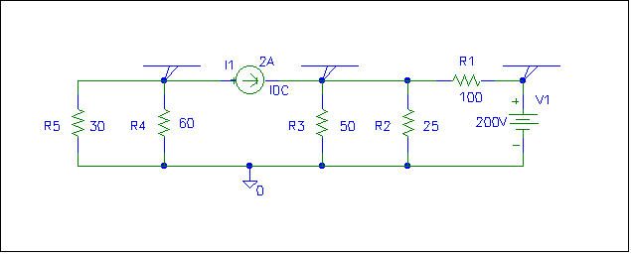
-10.0000
50.0000
14.2858

500 mA

50 V

P.P.3.11 The schematic is shown below. After saving it, it is simulated by choosing Analysis/Simulate. The results are shown on the IPROBES.

i ₁ = –428.6 mA, i₂ = 2.286 A, i₃ = 2 A

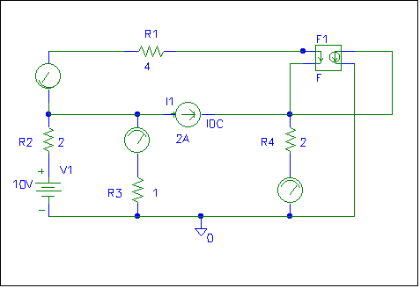
2.000E+00
2.286E+00
-4.286E-01

P.P.3.12 For the input loop,

-5 + 10 x 10³ I_{B} + V_{BE} + V₀ = 0 (1)

For the outer loop,

-V₀ - V_{CE} - 500 I₀ + 12 = 0 (2)

But V₀ = 200 I_{E} (3)

Also I_{C} = βI_{B} = 100 I_{B}, α = β/(1 + β) = 100/(101)

I_{C} = αI_{E} I_{E} = I_{C}/(α) = βI_{B}/(α)

I_{E} = 100 (101/(100)) I_{R} = 101 I_{B} (4)

From (1), (3) and (4),

10,000 I_{B} + 200(101) I_{R} = 5 - V_{BE}

I_{B} =

V₀ = 200 I_{E} = 20,000 I_{B} = 2.876 V

From (2),

V_{CE} = 12 - V₀ - 500 I_{C} = 9.124 - 500 x 100 x 142.38 x 10⁻⁶

V_{CE} = 1.984 V {often, this is rounded to 2.0 volts}

-

+

1V
-

+

20V

30 kΩ

i_{B}
+
V_{BE}
–

10 kΩ

10 kΩ

i_{C}

i₁

i₀
+

–

P.P.3.13

i_{B} = i_{C} = βi_{B} = 0.8 mA

i₁ = i_{C} + i₀ (1)

Also, –10ki₀ – 10ki₁ + 20 = 0 i₁ = 2 mA – i₀ (2)

Equating (1) and (2),

2 mA – i₀ = 0.8 mA + i₀ i₀ = 600 μA

v₀ = 20 ki₀ = 20x10³ x600x10^{–6} = 12 V

